Migrating a Course from ANGEL to Generals Online

Before beginning: Prepare your ANGEL course for migration to GO by following the instructions on the “Checklist of Course Preparations” handout.
First step: Export the course from ANGEL.
Sign in to ANGEL, then enter the course you want to migrate.
Click the Manage tab.
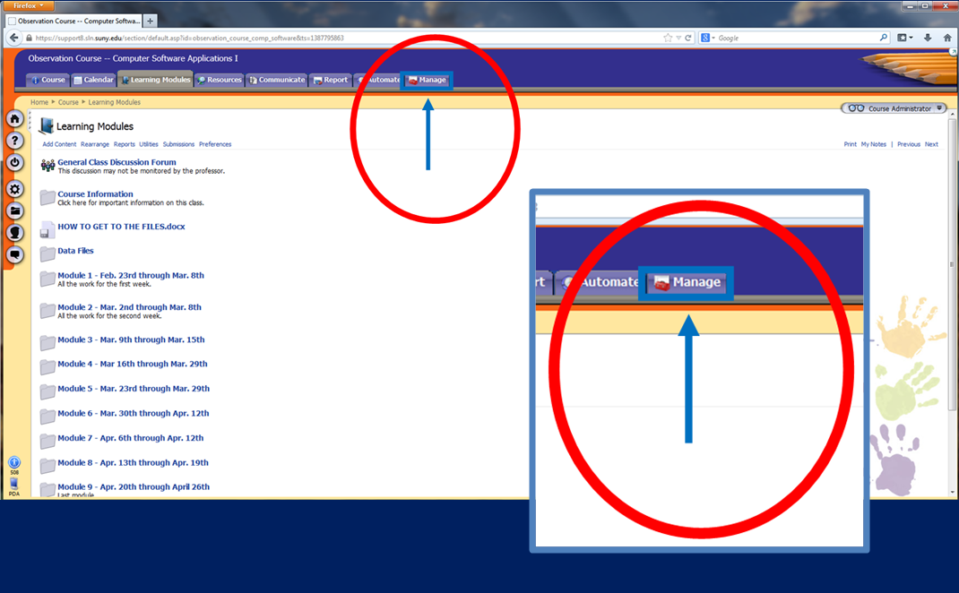

Click Export Console.
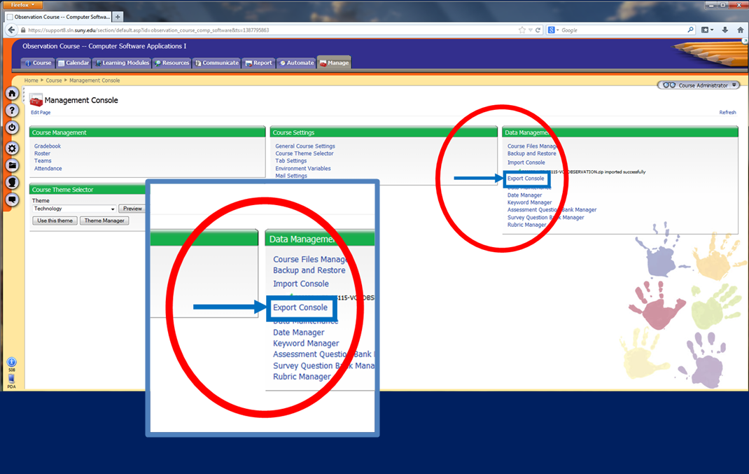
Click ANGEL format.
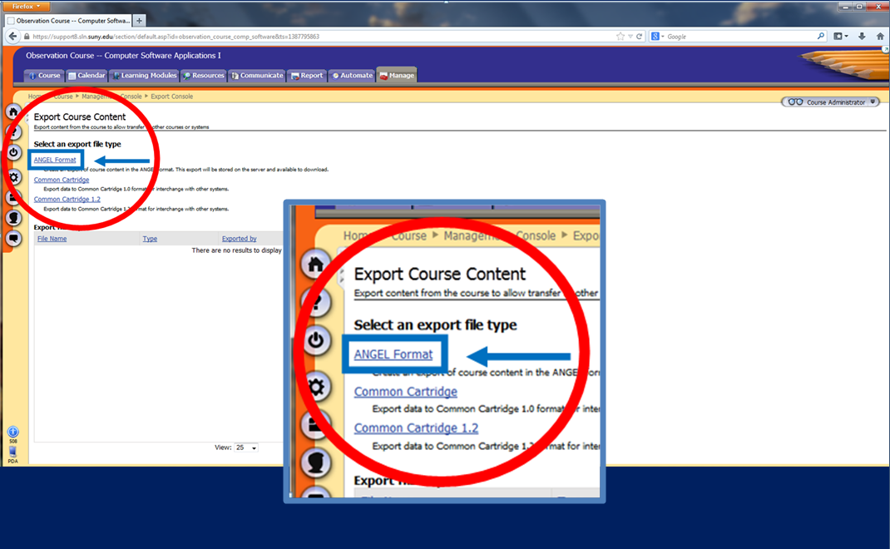

Keep all the default selections and click Next.
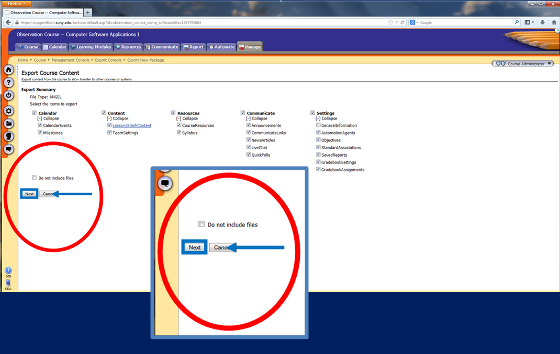
The following Export Status screen will appear telling you that your content is being exported. The export may take a few minutes, but you can navigate away from the screen while you wait.
Click on Go back to Export Course Content to obtain your export file.
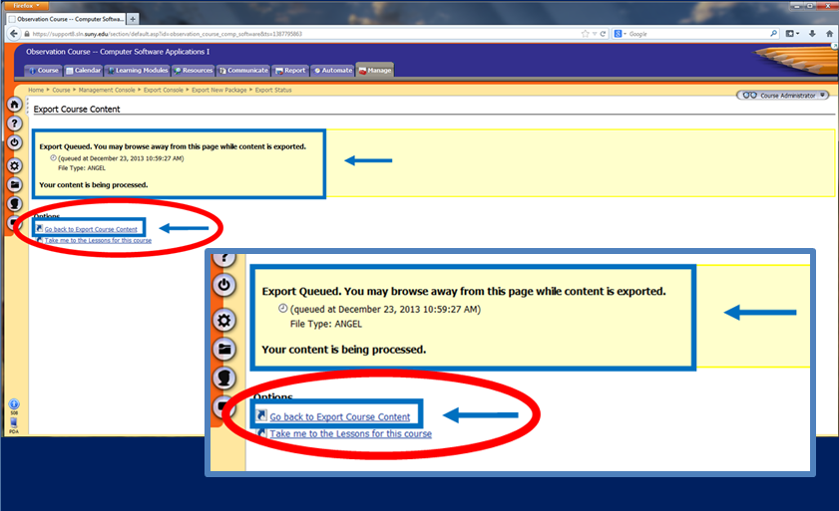

The next screen should show your newly exported course file in the export history and under the ANGEL Format heading. Click Download File next to your last export under the ANGEL Format heading.
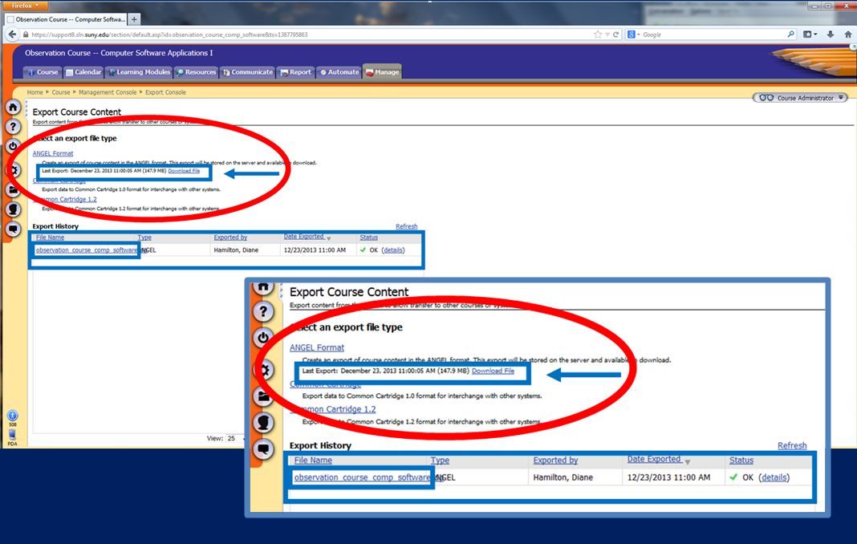
The zip file containing the course will be found on your computer wherever your downloads go automatically (perhaps My Computer > Downloads). Its name will be YourCourseTitle.zip.

Second step: Ensure that your new course shell in GO is empty and that you are enrolled as an instructor before importing the content from your ANGEL course zip file.
Sign into GO and click the title of the course shell for the course you want to import.
Click Content in the course menu at the left to ensure that there is no content in the course shell yet. (If there is content, STOP. You may be in the wrong course shell.)
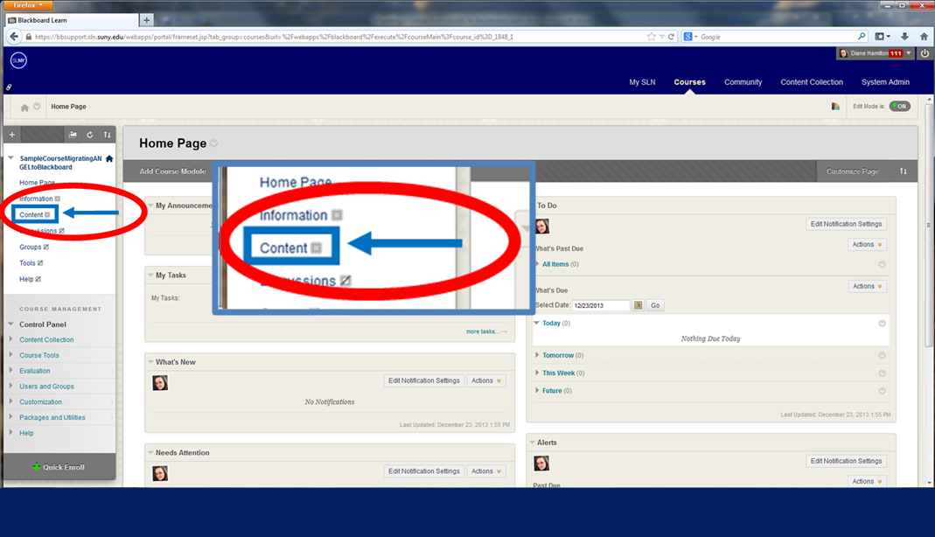
If there is no content, then the course shell is ready for you to import your course zip file.

Third step: Import the course into your new course shell in GO.
Sign into GO and click the title of the new course shell for the course you want to import, then click Packages and Utilities near the bottom of the course menu on the left.
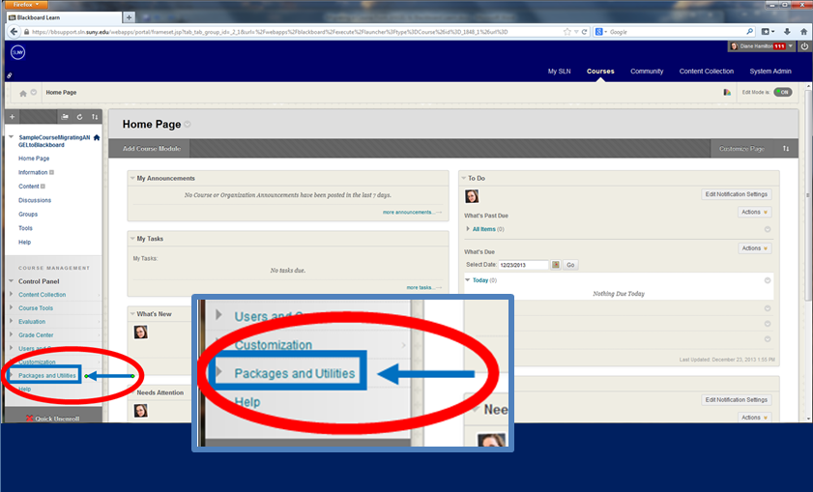
Click Import Package/View Logs (NOT Import Course Cartridge).
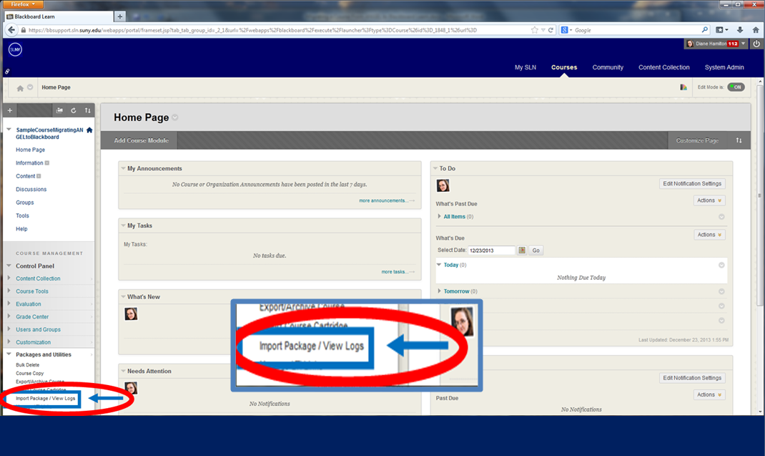

Click Import Package.
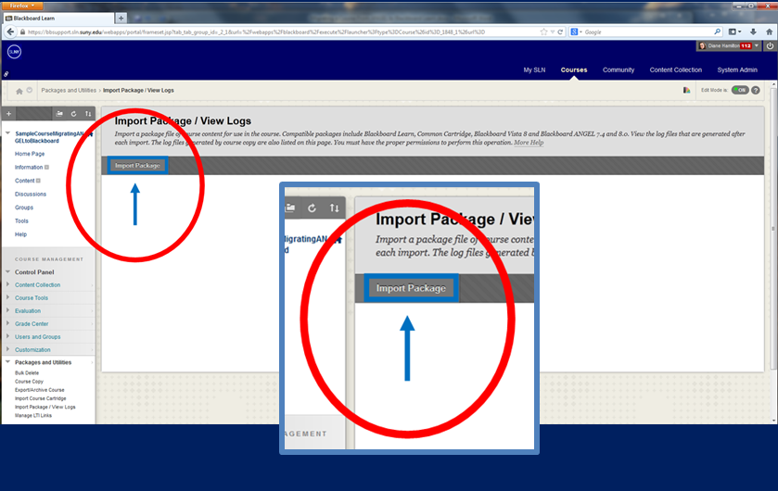
Browse your computer for the course export zip file you created when exporting from ANGEL, then click Select All, Change the Discussion Boards setting to “Include only the forums with no starter posts” and click Submit.
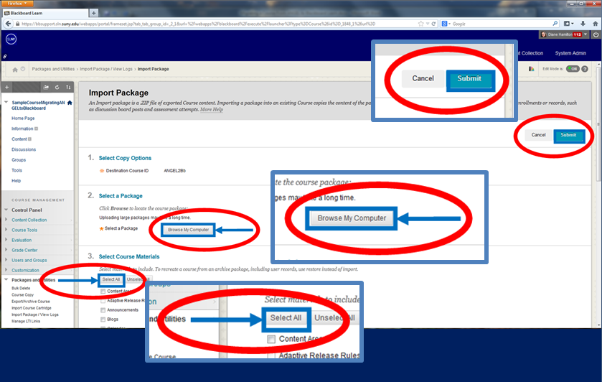

The following screen will appear indicating that the import is running and an email will be sent when it is finished. Note that the message may indicate that the import failed, but it probably did not fail. It may simply have encountered some incompatibilities. You can click in the message to see the detailed log of imports and your import should be listed there. (If you have questions about the success of your import, you can contact your Division GO Liason, Bill or Tabbi.
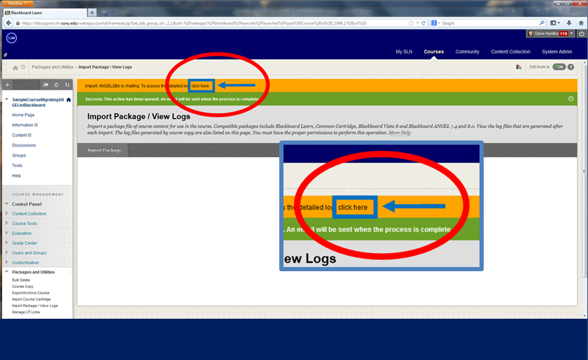
If you clicked to see the detailed log, you will see the screen below and your import will be listed. Click Content in the course menu to view the imported contents.
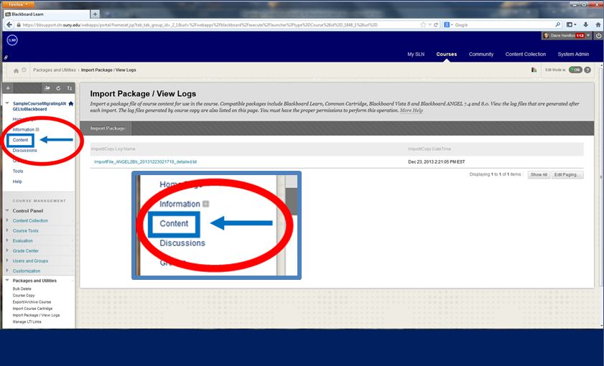

The course has now been exported from ANGEL and imported into GO.
Using the chevron to the right of each document and folder, move all of the items from the “Content” link to the “Learning Modules” link, then delete the “Content” link.
Make adjustments/revisions to the Learning Modules documents and folders as needed. If there are problems - or if you are missing any content - contact your Division Uber Pilot for assistance.
