Mission Statement  The Academic Support Center’s mission is to encourage and empower students of all abilities and backgrounds to reach their fullest learning potential, while striving to meet their academic goals, degree requirements and career aspirations.  Personalized Approach to Success  Our Academic Coaches utilize Starfish, an early alert system, which fosters communication between a student and their success network. The use of Starfish helps coaches work collaboratively with students to achieve academic and social integration into the Herkimer College community.  Interested in academic coaching?  If you are interested in working with an Academic Coach—please reach out! Stop by the Academic Support Center or give us a call to schedule an appointment!  Herkimer County Community College  100 Reservoir Road, Herkimer, NY 13350  Herkimer, NY 13350  Phone: 315-866-0300 x8275  Web: https://www.herkimer.edu/learn/academic-support-center/  1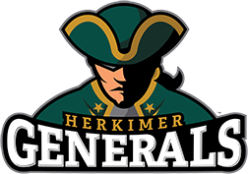 ACADEMIC SUPPORT CENTER Herkimer County Community College 100 Reservoir Road, Herkimer, NY 13350 Herkimer, NY 13350 |  |  | 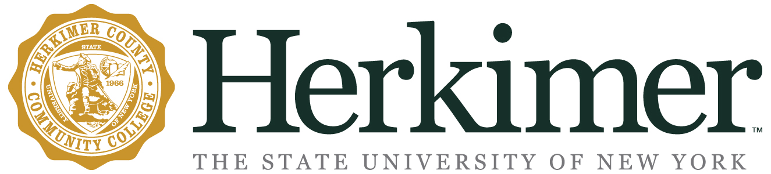  Academic Coaching  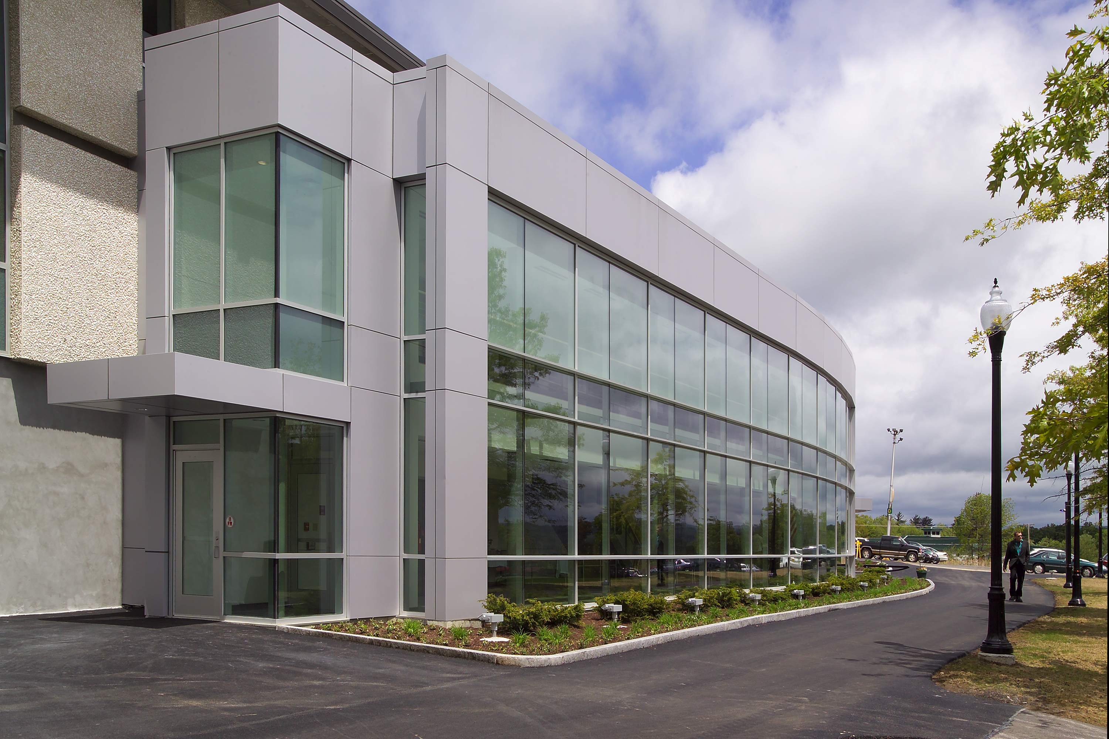  ACADEMIC SUPPORT CENTER  - Library 104

What is academic coaching?  The National Academic Advising Association (NACADA) defines Academic Coaching as: “…an interactive process that focuses on the personal relationship created between the student and the coach. The coach challenges the student to think about their personal and professional goals in order to relate them to their academic/educational goals. In this learning process, it is important for the coach to encourage the student to become more self-aware by understanding their strengths, values, interests, purpose, and passion.”  “Personal connections are often the central mechanisms and daily motivator of the student experience.” –Daniel Chambliss, How College Works  Academic Coaches can assist with:  - Time Management  - Goal Setting  - Study Skills  - Interpersonal Communication Skills  - Stress Management  - Organization | “ |  | Meet our coaches!  Jody Edick  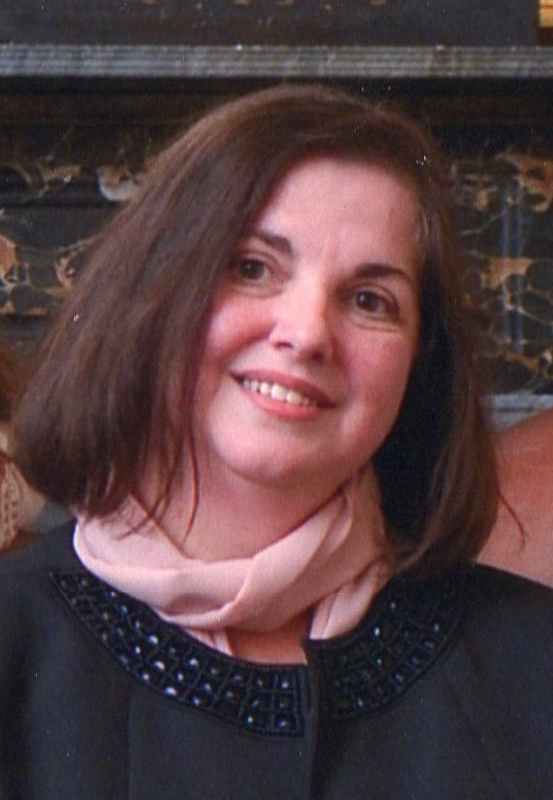 Jody assists students who major in General Studies. She works with students to improve their academic skills and supports them to connect with college resources. Areas of research include: frameworks for understanding teaching and learning, and First Generation Student success.  Keith Heinrich  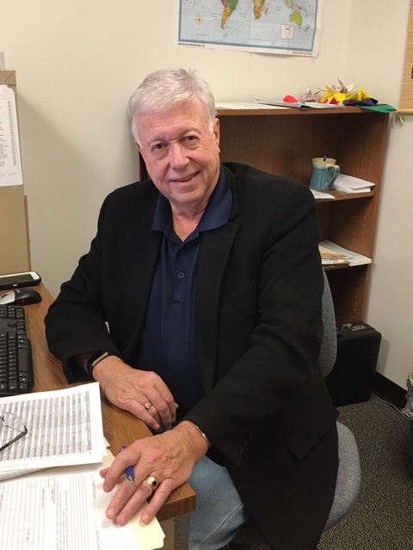 Keith collaboratively works alongside our Services for Students with Disabilities office to provide individualized coaching for our Career and Technical Education (CTE) students.  Hannah Stubley  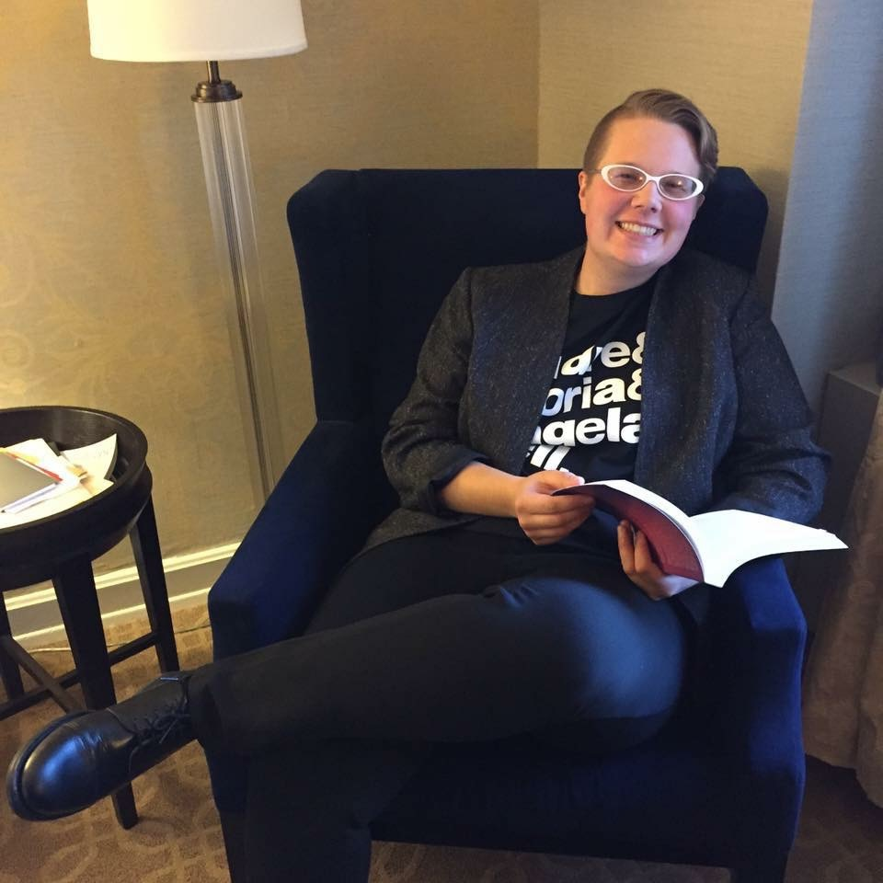 Hannah is a proud Herkimer alum who works with CTE students on time mastering tools needed to navigate college, such as organizational skills, time management and study strategies. Research interests include class in higher education, inclusivity, and feminist pedagogy.

